TECHNICAL PROPOSAL

**SIDMACH TECHNOLOGIES NIGERIA LIMITED**

www.sidmach.com

TO

**PHARMACEUTICAL SOCIETY OF NIGERIA (PSN)**

FROM

|  |  |
| --- | --- |
|  |  |

04/04/2013

November 4, 2015

The Director General

National Information Technology Development Agency (NITDA)

28, Port Harcourt Crescent, Off Gimbiya Street, Area 11, Garki,

Abuja,

Dear Sir,

**DEVELOPMENT OF DIGITAL PLATFORM FOR NIGERIA HEALTHCARE SYSTEM (NITDEF/RFP/ITIS/RP05/2015)**

With reference to your recent advert on the above subject matter, we are pleased to forward to you, our proposal for the project.

The project will serve as a reference point for ensuring that interactions within the healthcare system become digitalized and therefore more efficient and cost effective in Nigeria. The solution also provide a framework for interoperability among e-Health services providers in the country.

Please find attached our technical proposal, requested supporting documents on this area of interest, and soft copy of proposal in USB.

Our proposal would be valid for 20 weeks from the deadline for bid submission

We look forward to being shortlisted as preferred bidder to deliver on this project.

Thank you.

Yours faithfully,

**For: Sidmach Technologies Nigeria Limited**

Hassan Alao,

Executive Director

**TABLE OF CONTENT**

**Pages**

1. Executive Summary 5

2. Project Objectives 6

3. Project Benefits 7

4. Scope of work 8

5. Detailed Technical Description 9-14

* Project Deliverables
* Project Design & Architecture
* Overall System Design workflow

6. Technical Support and Training 15

7. Preliminary Project Plan 16-18

* Project Duration

8. Project Methodology 19-25

9. Resource Schedule 26

10. Eligibility Documents 27

* Evidence of having structure that possesses both human and material resources
* Evidence in ICT/software deployment
* Evidence of relevant Technical Experience with verifiable reference
* Evidence of incorporation with Corporate Affairs Commission.

(Certified True Copies of Certificate of incorporation and form CO7)

* Certified True Copies of Articles and Memorandum of Association
* Genuine Three year Tax Clearance certificates
* Evidence of compliance with Pension Act 2004 including evidence of remittances
* Evidence of registration with ITF
* Evidence of financial capacity to execute the project supported with bank statement
* Company profile and organizational structure, including names and resume of key personnel and technical staff with phone numbers and addresses
* Sworn Affidavit.
* Confirmation of Responsibility

|  |
| --- |
| EXECUTIVE SUMMARY |

# Executive Summary

The Pharmaceutical Society of Nigeria (PSN) being one of the largest association of healthcare professionals has requested for an expression of interest for the provision and development of an integrated system to facilitate the modernization of Nigeria's drug distribution network.

PSN proposes an integrated system that will deliver the following:

1. A comprehensive IT driven pharmaceutical industry from the point of source(local/import) to the consumers of medicines in Nigeria
2. Enable track and trace of medicines and allied products in the supply chain.
3. Harness the information of registered practitioners and products on a single platform.
4. Create access for the consumer of health for information on products and their feedbacks.
5. Generate data for the use of the pharma sector.

This solution will manage the distribution of medicine and allied products from the point of source to consumers in accordance to the new drug distribution guidelines, manage data on registered pharmacists, distributors and pharmaceutical premises whilst liaising with the National Agency for Food and Drug Administration (NAFDAC) and the Pharmaceutical Council of Nigeria (PCN) to ensure the integrity of data within the system.

It will also provide an avenue for consumers of health to access information on medical products and offer feedback to relevant authorities.

The consequence of implementing this solution will be that the movement of all medicines sold in Nigeria along the value chain as defined by the NDDG can be tracked from entry to consumer and accurate data on pharmaceutical distribution will become easily accessible.

This phase of the project is targeted at

Sidmach Technologies Nigeria Limited, is pleased to submit this proposal. SIDMACH recognizes the importance of this initiative as it represents a major commitment to the overall mission of creating a health care system that is technology driven, efficient and organized.

# System Description

The system will be designed in such a way to cater for the tracking of movement of medicines and other allied products through the distribution network. It will cater for marking individual packets of products with a unique identifying code upon entry into the country by the Importer/Manufacturer which be used to track its movement via sale to distributors, retail outlets and then unto consumers.

Acquisition of the data on the cost of medicines, time of arrival and time of departure from every premise in the value chain is of uttermost importance because it is this data that forms the backbone of everything that is of value to the solution.

This proposal is intended to design an interface that will interact with the users at each level and possibly with third party applications that may be employed in achieving the goals set by PSN.

There are 9 parts to this solution:

1. Module for Importers/Manufacturers
2. Module for Distributors/Wholesalers
3. Module for Hospitals
4. Module for Retail Outlets
5. Module for PCN
6. Module for NAFDAC
7. An app for Consumers
8. An app for Geo-Location
9. Admin Module



## Importers/Manufacturers

These are the first point of entry for all drugs in the country and are tasked with creating the identification codes for each drug on the system. They consist of companies who manufacture medicines locally or import medicines from multinational corporations.

Their activities are:

1. Register Premises (With Valid certification and License Numbers from PCN)
2. Geo-Locate Premises
3. Create Product list (Must be a NAFDAC registered or Approved product)
4. Register source
5. Create Staff Operator Profiles
6. Create Inventory of products with prices
7. Auto-generate unique identification codes (Packet Code and Box Code)
8. Tag packets of product with unique packet code
9. Tag boxes of packets with unique box code
10. Create directory of clients
11. Record sale transactions of products to clients
12. Receive Messages from NAFDAC and PCN and report incidents.

### Storyboard

An importer will register his premises on the platform. His registration details will include the licenses which will be verified by PCN. The registration process will be self-provisioned. The details he will provide are Establishment Name, Address, Phone Number, Email, Alternate Phone Number, Logo, State, City, then use the Geo-Locator application to capture the GPS coordinates of his premises. He will then register his staff or the terminals by which the solution can be accessed. After completing this task, he will register the products he sells - this information will contain details of the companies that his drugs are sourced from.

These products must be from a list of registered drugs as supplied by NAFDAC, whist registering the products he will provide the following information: Product Name, Active Ingredient, Product Source, Price, Category, NAFDAC Number, Product Description. The Importer will then tag the boxes in which a particular group of already identified drugs are enclosed.

The Importer will create a client list from the list of registered distributors and wholesale premises as provided by PCN. When an order is received from a client, the Importer will scan and identify which boxes are being sold and the price and the system will store that information. When a box is scanned all individual products in the box will be recorded as sold. When the importer receives more stock, he will repeat the product registration process with the products he has received.

The importer can also receive messages from NAFDAC and PCN concerning policy and regulation.

## Distributors/Wholesalers

These are the middle men between the Importers and Retail Outlets. In this system their role is to ensure that only products with authentic packet and Box codes are distributed to all parts of the country.

Their key activities are:

1. Register Premises (With Valid certification and License Numbers from PCN)
2. Register Suppliers (From list of registered importers/distributors provided by PCN)
3. Geo-Locate Premises
4. Create a list of products that they distribute (Must be a NAFDAC registered or Approved product)
5. Create and manage inventory with associative prices
6. Buy products from Importers/Manufacturers
7. Sell products to Hospital and Retailers
8. Scan received box codes and record associated packet codes
9. Create Staff Operator Profiles
10. Create Inventory of Stock with prices
11. Create directory of clients
12. Check validity of Box and Packet codes
13. Record sale transactions of products with clients
14. Receive Messages from NAFDAC and PCN and report incidents.

### Storyboard

A distributor will register his premises on the platform. His registration details will include the licenses which will be verified by PCN. The registration process will be self-provisioned. The details he will provide are Establishment Name, Address, Phone Number, Email, Alternate Phone Number, Logo, State, City, then will use the Geo-Locator application to capture the GPS coordinates of his premises. If any of these details are verifiable by PCN, any such data available will take precedence. He will then register his staff or the terminals by which the solution can be accessed. After completing this task, he will register the products he sells - this information will contain details of the importers/manufacturers that his drugs are sourced from. These products must be from a list of registered drugs as supplied by NAFDAC. The distributor while scanning the products he receives from the Importer/Manufacturer, will scan the box code and all the packets within that box will be logged.

The distributor will create a client list from a selection retail outlets as provided by PCN and create a list of hospitals manually. The inventory list will contain the list of drugs available and their correspondent prices. When a product is sold, the system will log such transactions, retaining the original packet and box codes.

The distributor can also receive messages from NAFDAC and PCN concerning policy and regulation.

## Retail Outlets/ Hospitals

These are the premises that sell directly to consumers. In this system their role is to ensure that consumers get only products with valid box and packet codes.

Their activities are:

* 1. Register Premises (Validated by PCN records)
  2. Geo-Locate Premises
  3. Register Suppliers (From list of registered Distributors and Wholesalers provided by PCN)
  4. Register Products (From list of registered NAFDAC drugs)
  5. Create Staff Operator profile
  6. Create and manage inventory with associative prices per product.
  7. Register clients. (Using email as unique identifier)
  8. Store sales records to consumers to form part of drug consumption history
  9. Issue prescription
  10. Fulfill prescription
  11. Create and manage consumer medical records.
  12. Validate authenticity of Packet and Box Codes
  13. Receive Messages from NAFDAC and PCN and report incidents.

### Storyboard

A retailer/hospital will have this system to log drugs bought and sold to its clients. This could be done in app or by collaboration with 3rd party solution. The retailer will first register and geo-locate his premises. Then he will register his staff operators. When he buys medications, he will log it in by the unique identifier code on the packet of the product. He can also pre-verify whether the code he is logging in is authentic or not. When a consumer buys medications from him, he registers the sale via a POS application which now logs the sale to the consumer's email ID on the platform. He also has the ability to issue a prescription attached to the consumer's email ID that is accessible by any other pharmacy or hospital.

The retailer or hospital can also receive messages from NAFDAC and PCN concerning policy and regulation.

## Consumers

They are the final consumers of drugs in the drug distribution network.

Key activities are:

1. Registration
2. Buying of medication and non-Rx products
3. Receiving prescription
4. Locate nearest registered pharmacy and hospital
5. Filing complaints (Communicate directly with NAFDAC)
6. Checking authenticity of Pack Codes
7. Inquiring about drug information (From PSN databank on Drugs)

### Storyboard

A consumer will register on his application. Using his email as a unique identifier he will have his purchases and prescriptions stored on the platform using that unique identifier such that if another pharmacy or hospital wishes to fulfil that prescription his email will suffice to identify him. He can also verify the authenticity of the drug via a simple query on the application that will check the particular code has followed all the distribution channels as recommended by the NDDG and the date and time it was sold (culling the record directly from the retailer or hospital's logs). That way, the consumer can know if the drug was sold to him or is a counterfeit.

The consumer can also file complaints directly to NAFDAC.

## NAFDAC/PCN/PSN (Regulator Module)

Their roles in the application as simply to provide data to authenticate the information supplied by the elements in the value chain.

## ADMIN

Admin's role is to manage the usership of the platform and mine data from the system on request.

# Business Processes

|  |  |  |
| --- | --- | --- |
| Business Process | Sub-Process | Activity in Platform |
| Supply Chain management | A single compendium of registered products,  practitioners and premises that governs the  supply chain system; with each having its own  unique identification code | Platform syncs with PCN and NAFDAC database to ensure integrity of data on Premises and Drugs. On registration, each Product, Importer, Manufacturer, Retailer, hospital and consumer is issued a unique identifying code. Products are issued codes on two levels, at packet level and at box level. |
|  | Create a compendium of orphan/service drugs  that is reviewable regularly | The method of syncing with NAFDAC and PCN database will be as such that when data is updated at their end it will immediately reflect on platform. |
| Order management | Ordering to follow the unique path of the  NDDG | Products that are sold to end users without following the distribution chain as recommended by the NDDG will be flagged. The system is structured so that at every level in the distribution chain, an entity cannot purchase drugs from a supplier that doesn’t have the license to sell to it. Eg. Retailers cannot register Manufacturers as suppliers. |
|  | Ordering conforms to the compendium | Only registered drugs as provided by NAFDAC can be bought and sold on the platform. |
| Product regulation & Licensing | Interface with existing database of NAFDAC | Platform synchronizes with NAFDAC database so that only drugs with NAFDAC approval/Number can be bought and sold. |
| Premises Licensing | Interface with existing database of PCN | Data from PCN database verifies all premises registrations. Buyers can only select from a pre-existing list of registered distributors (as supplied by PCN) in the registration process. |
| Patient Medical Records  management | To create standalone system for patients  medication history, allergies, idiosyncrasies,  adverse drug reactions viewable to  practitioners at retail and hospital pharmacies | This is incorporated in the retail module but will be built to synchronize with select third party applications as decided. |
| Pharmacist certification &  Regulation | Interface with existing database of PCN | Data from PCN database verifies all Pharmacist registrations. Only pharmacists are required to register. |
| Product information management | To interlink with the existing drug information  platforms e.g. PSN product information  platform | Consumers will be able to access drug information from PSN via the application as part of the features. |
| Electronic Prescription | Generate list of willing subscribers (private  hospitals) | The application can register any hospital as long as they have the required licenses which will be validated by the relevant regulatory body. |
|  | Subscribers to have a path to send electronic  prescriptions to preferred retail pharmacies on  the platform | Retail and Hospitals can create and share prescriptions. With his identifying email a consumer can walk into any pharmacy or hospital on the platform and request for his prescription be fulfilled. Records of who issued prescription and who fulfilled it can be easily accessed. |
| Product tracking & tracing (by  License & Location) | Geo - mapping of premises | We have already built this technology. The app will be deployed alongside the platform to be used by owners of premises to geo-locate themselves. |
|  | Unique codes for each pack of product  introduced into the supply chain | The unique codes will be provide for each pack and each box at the importer/manufacturer level of the value chain. |
| Health Management | Restricted access portal for Professional  information dissemination | Only registered pharmacists who have been verified via the platform’s synchronization with PCN’s database will have access to the platform. |
| Electronic point of sale(EPOS) | To capture transaction details on the shop  floor | This feature will be provided for access at all levels. The codes issued will also come in form of bar codes to simplify the Logging process by encouraging the use of an infrared scanner. |
| Pharmacovigilance and Products  Complaints | Leverage on the existing NAFDAC platform | At all levels, users can send inquires and complaints to NAFDAC. |

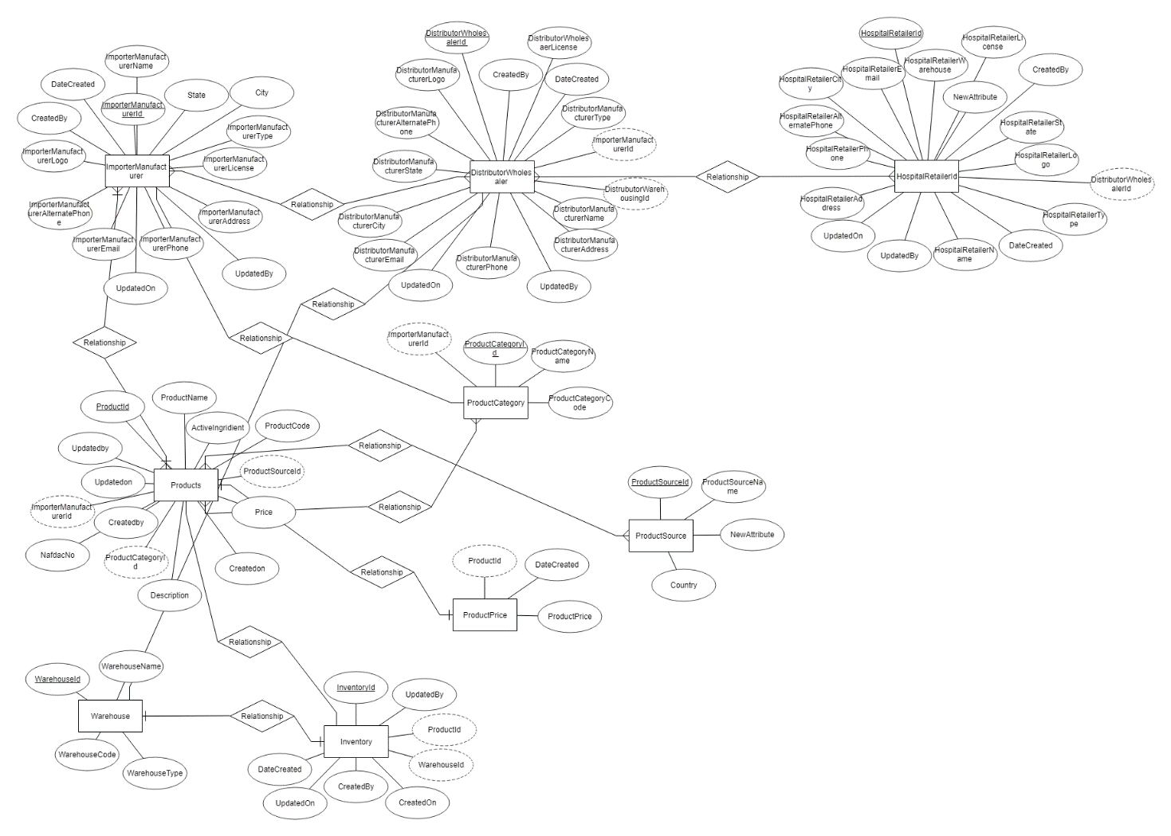

Fig. 1 ERD

